My
Feelings
Workbook

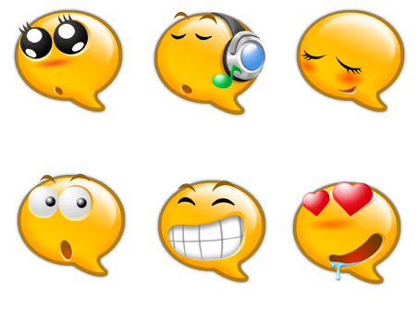

NAME:

Activity 1: Recognising different feelings

What feelings do people have?

There are many different feelings that people can have in different places, with different people and doing different things. This activity will help you to notice these different feelings in yourself and others.

- Choose a colour that represents the feeling shown by each face (eg red might show anger)

- Colour each face with colour you think that best fits the feeling.

- Next to the face, write down one feeling word that best describes the face (e.g angry, sad etc)

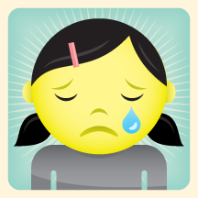 ____________________________________

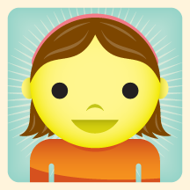 _____________________________________

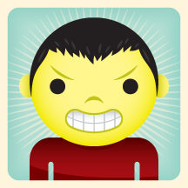 ____________________________________

Activity 2: Recognising my own feelings

What feeling goes where?

We have different feelings in different places. Use a different colour and draw a line from each place to the feeling that best describes how you feel.

In bed at night
With other children

RELAXED
SCARED
BORED
On my own
At school
SAD
HAPPY
WORRIED
ANGRY
At home
FRIGHTENED
EXCITED
CALM
UPSET
RELAXED

Activity 3: Showing our feelings

What do you usually do when you feel….

- Happy? _____________________________________

- Sad? _____________________________________

- Worried? _____________________________________

- Angry? _____________________________________

Now think about another important person in your life for example, best friend, mum, dad, sister etc. Write their name below.

Name: __________________________

What do they do when they feel…..

- Happy? _____________________________________

- Sad? _____________________________________

- Worried? _____________________________________

- Angry? _____________________________________

Activity 4: Identifying clues in our own body

When people are scared, their bodies give them signs that they are afraid. Let’s look at the clues Kelly Koala’s body gives her when she is feeling nervous or scared.

It is important to learn the signs your body gives you when you are feeling upset so that you can find ways to help calm yourself down and feel peaceful.

Activity 4: Identifying clues in our own body

How do I feel?

Think about how you feel when you first start to get angry. Tick any of the following statements that apply to you.

I feel hot ………………

My hands start to sweat ………………

I find it difficult to stay still, I get fidgety ………………

My mouth gets dry ………………

My hands go into fists ………………

My body feels tense ………………

My heart races ………………

I breathe more quickly ………………

I feel panicky ………………

Describe three other things that you have noticed about yourself when you are beginning to get angry:

1.

2.

3.

Activity 4: Identifying clues in our own body

- Draw a picture of your body

- Colour in the parts of your body which tell you when you are feeling angry/ worried/ sad

- Describe in words how each part of your body feels

Activity 5: Linking thoughts and feelings

Linking thoughts and feelings
Draw lines in different colours to match the pairs of thoughts and feelings. There are no right or wrong answers.

Thoughts | Feelings
I am having so much fun | embarrassed
No one ever wants to play with me | angry
My homework is so long and always the same | happy
I did something wrong in class | lonely
I heard a scary noise | nervous
Who’s taken my lunch box? | bored
My friends are scared about giving an oral presentation in front of the class. I will practice with them | scared
I’ll never be good at English. I want to give up | helpful
I have butterflies in my tummy and it feels funny | sad
I can do this? It doesn’t matter what happens as long as I try my best | Excited
I am going to have a great day with my friends | caring
Mum or Dad looks tired. I’ll tidy up for them | confident

Activity 6a: Putting it all together
What happens when I feel anxious?

Think about something that made you feel really anxious. How would someone else know that you felt like this?

What does your face look like when you feel anxious?

How does your body show that you are anxious?

What are the thoughts in your head when you feel anxious?

How do you behave when you are anxious?

How much of the time do you feel anxious?

Never All the time
1 2 3 4 5 6 7 8 9 10

Activity 6b: Putting it all together

What happens when I feel angry?

Think about something that made you feel really angry. How would someone else know that you felt like this?

What does your face look like when you feel angry?

How does your body show that you are angry?

What are the thoughts in your head when you feel angry?

How do you behave when you are angry?

How much of the time do you feel angry?

Never All the time
1 2 3 4 5 6 7 8 9 10

Activity 6c: Putting it all together

What happens when I feel happy?

Think about something that made you feel really happy. How would someone else know that you felt like this?

What does your face look like when you feel happy?

How does your body show that you are happy?

What are the thoughts in your head when you feel happy?

How do you behave when you are happy?

How much of the time do you feel happy?

Never All the time
1 2 3 4 5 6 7 8 9 10

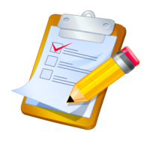Activity 7: Let’s Make Lists

We all have different feelings about situations that we have to do in our lives. Ask a family member about different feelings that they have about the things that they have to do. Write down the answers to the questions below.

A: List 3 things that you and a family member really like doing

I like 1. _____________________

2. _____________________

3. _____________________

My family member likes 1. _____________________

2. _____________________

3. _____________________

Draw a Picture of your favourite thing to do……

B: List 3 things that you and a family member sometimes feel anxious about doing

I get anxious about 1. _____________________

2. _____________________

3. _____________________

My family member 1. _____________________
gets anxious about
2. _____________________

3. _____________________

Draw a Picture of something you could do when you start to feel anxious….

Calming Activities

When you are feeling anxious or worried, it is important to learn to do things that make you feel calm and relaxed.

Read the stories below which tells of some things that our friends like to do when they are feeling angry or annoyed.

When George is worried he likes to go to his room and listen to music. This helps him to feel calm and relaxed.

When James feels anxious he likes to go to the garage and use his punching bag. He punches all his anxious feelings into his punch bag.

When Kate feels scared of something, she leaves the room, counts to ten and does some calming exercises. This stops her from feeling scared.

When John feels anxious he goes to his room and writes his feelings into his diary. He draws pictures when he doesn’t want to write. Then when he feels calm he talks to someone. He says things like: “I felt anxious when I couldn’t hear you. But I was brave and wrote in my diary’.

What helps me to Stay Calm?

Put a ‘Y’ for Yes if it helps or an ‘N’ for No if it doesn’t

- Listen to music ___

- Count to ten ___

- Finding a quiet place / special place ___

- Breathe deeply & slowly ___

- Relaxation Exercises ___

- Talking to yourself about feeling calm ___

- Taking exercise-running, punch bag, skipping ___

- Pretending to be somewhere else ___

- Using the turtle technique. Pretend to protect yourself inside your shell ___

Feeling Calm

Make a list of six things that would help you the most to stay calm and stop you from getting angry.

- __________________________________________

- __________________________________________

- __________________________________________

- __________________________________________

- __________________________________________

- __________________________________________

I can do it!

I can try my best!

Self-talk

I can think of calming activities

I can remember to think of helpful thoughts

I can stay calm if I choose to.
Lets Practice!!

Think of a situation that when you got anxious.
Break it down into small steps.
Fill in each of the boxes below with how you could now stay calm.
The bottom step should be the easiest step, gradually working up to the most difficult step. Remember that you can use your ideas from earlier to help you along the way eg thinking helpful thoughts, taking deep breaths etc.

Learning to relax

There are different ways in which you can learn to relax

Physical Relaxation

This method usually takes about 10 minutes and is very useful if you feel constantly tense or wound up.

- Choose somewhere warm and quiet
- Sit in a comfortable chair or lie on your bed
- Choose a time when you will not be interrupted
- Tense your muscles just enough to notice what it feels like. Don’t overdo it
- Tense your muscles for about 3-5 seconds
- Tense each muscles group twice
- After you have tensed a muscle, try not move it again

Quick Relaxation exercises

Arms and Hands: Clench your fists and push your arms straight out in front of you.
Legs and Feet: Push your toes downwards, gently raise your legs, and stretch them out in front of you.
Stomach: Push your tummy muscles, take a breath and hold it.
Shoulders: Scrunch up your shoulders
Face: Screw up your face, squeeze your eyes tight and push your lips together.
Neck: Push your head back against the chair or bed.

Physical exercise
Some people find that physical exercise is as effective as systemically tensing and relaxing their muscles. A good run, quick walk or swim can help you to get rid of any angry or anxious feelings.

If physical exercise works for you, then use it. It may be particularly useful to try it at those times when you notice strong unpleasant feelings.

Controlled breathing
There are times when you may suddenly start to become tense or angry, and on these occasions, you won’t have time to go through the relaxation exercises.

Controlled breathing is a quick method in which you concentrate and gain control of your breathing.
Slowly draw in a deep breath, hold it for five seconds and then slowly let it out. As you breathe, say to yourself “relax”. Doing this a few times will help you to regain control of your body and help you feel calmer.

Calming pictures
Think about your dream place. It could be somewhere you have been or an imaginary place. Imagine a picture of it and make the picture as restful and peaceful as possible.

Practice imagining your relaxing place, and if you start to feel unpleasant then try turning on your picture. Really concentrate hard on your restful scene and see if it helps you to relax

Relaxing activities

There will probably be some things that you enjoy doing and which make you feel good. Examples of these might include;

- Reading a book
- Watching TV
- Listening to music
- Taking the dog for a walk

